UCCE San Diego County, Floriculture Farm Advisor
760-752-4715
bethke@ucr.edu
Floriculture News & Notes


December 2006
Volume 1, Issue 12
The IR-4 Project (Inter-Regional Project) is a program largely funded by the U.S Department of Agriculture (USDA) and the State Agriculture Experiment Stations (SAES), and its mission is to provide registration support for conventional crop protection chemicals and biopesticides on minor use crops, which include ornamental horticulture greenhouses and nurseries, landscape, Christmas tree farms, sod farms and interiorscapes.
Within the last few years, IR4 has concentrated on identifying the needs of the ornamental industry by bringing together university scientists and extension personnel, growers, and the chemical industry to established high priority projects. I had the privilege of attending last year’s program, and it began by selecting the most persistent and difficult pests in each discipline, plant pathology, entomology, and weed science. Next, we made a list of potential management tools to be tested. Obviously, some are not registered and need data to support their registration. Others are registered but need further data for label expansion to include plants tested for crop safety and other pests. This is a win win for the ornamental and chemical industry because growers can see the results of efficacy testing against common pests, the pest management arsenal is increased, and the chemical industry can use the data in registration.
IR4’s goals for the future include:
1. Continued commitment to food-use and ornamental minor crop pest management.
2. Accelerate the registration of newer, reduced risk chemistries.
3. Focus on new and safer chemistry-speeding access for minor crop growers.
4. Conduct efficacy research to identify new minor crop pest management solutions
See this web site: http://ir4.rutgers.edu/

IR4: Supporting you

334 Via Vera Cruz, Suite 152
San Diego, CA. 92078

Phone:
760-752-4715

E-Mail:
bethke@ucr.edu

Society of American Florists

Pest Management Conference 2007
February 22-24
Portland Doubletree Lloyd Center
Portland, OR

Threatening Pests and Diseases
I’m sure most of you are aware that Diaprepes has finally made it into the nursery. The protocol being developed by the CDFA in Sacramento was not quite complete, but it’s what we have to work with. I don’t have enough room here to spell it all out to you. What you should do is be aware of where you are with respect to a quarantined area and be aware of what pesticides you will need to comply with the protocol. The CDFA is under a mandate to act in the quarantine, but they also are aware of the industry’s need to continue to do business.
There are three pest stages that are critical with respect to eradication, and there are three pesticides that you should be aware of, Sevin (carbaryl) for adults, Dimilin/Adept, (diflubenzuron) for eggs, and Talstar (bifenthrin) for the soil borne larval stage. There is also a predatory nematode that will be important during treatment of long term crops, but the availability and the efficacy is still in question. The protocol is tailored for the diversity of the industry, so that every plant and pot type in the industry is covered.

UCCE San Diego County, Floriculture Farm Advisor

Threatening Pests and Diseases, Cont.
A second pest that will have an impact on the ornamental industry is one that I mentioned earlier in the year, the Asian Citrus Psyllid. The insect is an efficient vector of Citrus Greening, a phloem-limiting bacterium that was detected for the first time in the US (Florida) last year. Citrus Greening is one of the most serious diseases in the world on citrus. In countries where the disease is endemic, the life span of trees is reduced from 50 to 15 years. In addition, infected trees live only 3-5 years before death. There is no known cure for the disease so infected tree removal is the only solution.
This last week the Asian Citrus Psyllid was found well established in Mexico. More or less, we are surrounded, and the citrus industry has been preparing for the invasion for a while now.
What does that have to do with you? The Asian Citrus psyllid was first detected in Florida in 1998 and spread rapidly via nursery stock (orange jasmine) to 30 counties by 2001. In addition, they were shipped to Texas via nursery stock (Orange Jasmine) in 2001 as well. USDA/APHIS immediately ordered the halt of all shipments of citrus and citrus related hosts (ornamentals) from Florida to California and other citrus growing states.
The citrus industry in CA will act just as the grape industry during the Pierces Disease crisis and the glassy-winged sharpshooter. The citrus industry has already set a long-term goal to strengthen the exclusion programs of ornamental plant material

334 Via Vera Cruz, Suite 152
San Diego, CA. 92078

Phone:
760-752-4715

E-Mail:
bethke@ucr.edu

Japanese Dodder

See the pest alert at the following web site:
http://www.co.contra-costa.ca.us/depart/agriculture/dodder.html

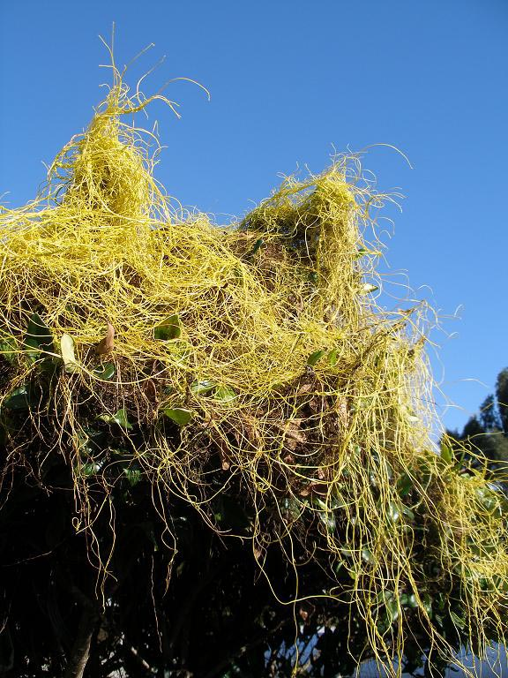

More pests and diseases

Japanese dodder
FYI, if you haven’t already heard about this one. Japanese dodder (Cuscuta japonica) has been introduced into California and you should be watching for it in the nursery, greenhouse, and surrounding areas. Japanese dodder is an annual, parasitic vine that has is commonly used by Asian cultures as an herbal remedy. The CDFA considers it a “Q” rated noxious plant, and it is listed as a Federal noxious weed. The dodder itself looks very similar to a thick diameter spaghetti noodle that is bright yellow-orange. It parasitizes host plants by penetrating the vascular tissues with structures called haustoria, and severe infestations can completely engulf host plants draping to the ground potentially killing the host plant. Japanese dodder was found for the first time in California in the summer of 2004 in Redding and in Yuba County in 2005. It is native to Asia and there are infestations in Texas, Florida, and South Carolina.
canna yellow mottle virus
In speaking with Ann Chase of Chase Research Gardens and Pat Nolan the plant pathologist for the San Diego County Ag Commissioners Office, the canna yellow mottle virus (CYMV) has been causing problems for 3 years at least. Ann says she sees it everywhere she goes. She recently observed it in Oregon and always sees it in California where they grow Cannas. Due to the ‘Q’ rating and no treatment available, some San Diego growers have to dump Tropicana Canna Lily because of the virus, and Santa Barbara County has followed suit. Pat says that the infected cannas look bad, with an odd mottle going into necrotic streaks on the leaves. Pat warns, “Exotic viruses coming in on ornamentals is happening more and more frequently. Growers seem to know they've got them, and need to make a better effort to clean them up. Eventually when we find them and because the grower has not reported it and not worked with a university to get it characterized (virus family and host range are important to determining a threat to agriculture), the virus is invariably given a Q rating.”
Regulatory agencies are going to be less forgiving with very serious agricultural viruses on the horizon.

We’re on the Web!
See us at:
www.cesandiego.ucdavis.edu/

