UCCE San Diego County, Floriculture & Nursery Farm Advisor
760-752-4715
bethke@ucr.edu
Floriculture & Nursery
News & Notes


December 2007
Volume 2, Issue 12
I have visited the web site that Valerie talks about in this feature, and it’s quite amazing. I was very impressed with the maps that you can access that shows what areas have burned recently verses what has not been touch yet. In addition, the maps are annual, which means that you can see how the fires have burned the county well back in the past. Tracking back, I was struck by how much more area burns in the more recent fires related to what has happened in the past. Thanks to Val for presenting this information.

by Valerie J. Mellano, Environmental issues Advisor, UC Cooperative Extension, San Diego County

Wildfire outreach and education program is designed to prepare the public before the next wildfire.

Since the San Diego wildfires of 2003, there has been a push to provide more information to the public about what to do before a wildfire, what to do during the fire, and how to pick up the pieces and move on after a wildfire damages your home or your property. The Farm and Home Advisors’ Office has developed a program that will help the residents of San Diego County prepare for these issues, and hopefully minimize the impacts that a wildfire can have on the lives of many of our residents.

The first stop for information gathering should be our newly developed Web site, www.wildfirezone.org. This Web site is specific to San Diego County residents, and has information based on your zip code. Input your zip code and you will find listings of fire agencies, ordinances related to wildfire and brush clearing and numerous other resources for that area. In addition, there is an Upcoming Events section that lists community-based programs and their activities, Fire Safe Council meetings, disaster preparedness meetings, etc. The Web site also contains general information about maintaining your home, decks, grounds and other fire-related issues.
We have also designed and printed “Tip-Cards,” each covering one topic related to fire safety and preparedness. For example, one Tip Card may cover the topic of roofs, and how to have the most fire-safe roof possible. Currently, these cards are available through public agencies, the San Diego County Farm Bureau, and by request from our office at (858) 694-8955. Public service announcements are also being developed for each topic covered by the Tip-Cards.

Other fire-related research and extension projects are also underway, including summaries of fire-related literature for the San Diego area, plant flammability, and water management and flammability of landscape plants. We will provide updates as we generate more information. Program funding has been provided by several sources, including the County of San Diego, FEMA, USDA Renewable Resources Extension Act and the University of California.

334 Via Vera Cruz, Suite 152
San Diego, CA. 92078

Phone:
760-752-4715

E-Mail:
jabethke@ucdavis.edu

Poomacha Fire Damage in San Pasqual

Baby Blue Eucalyptus is gone

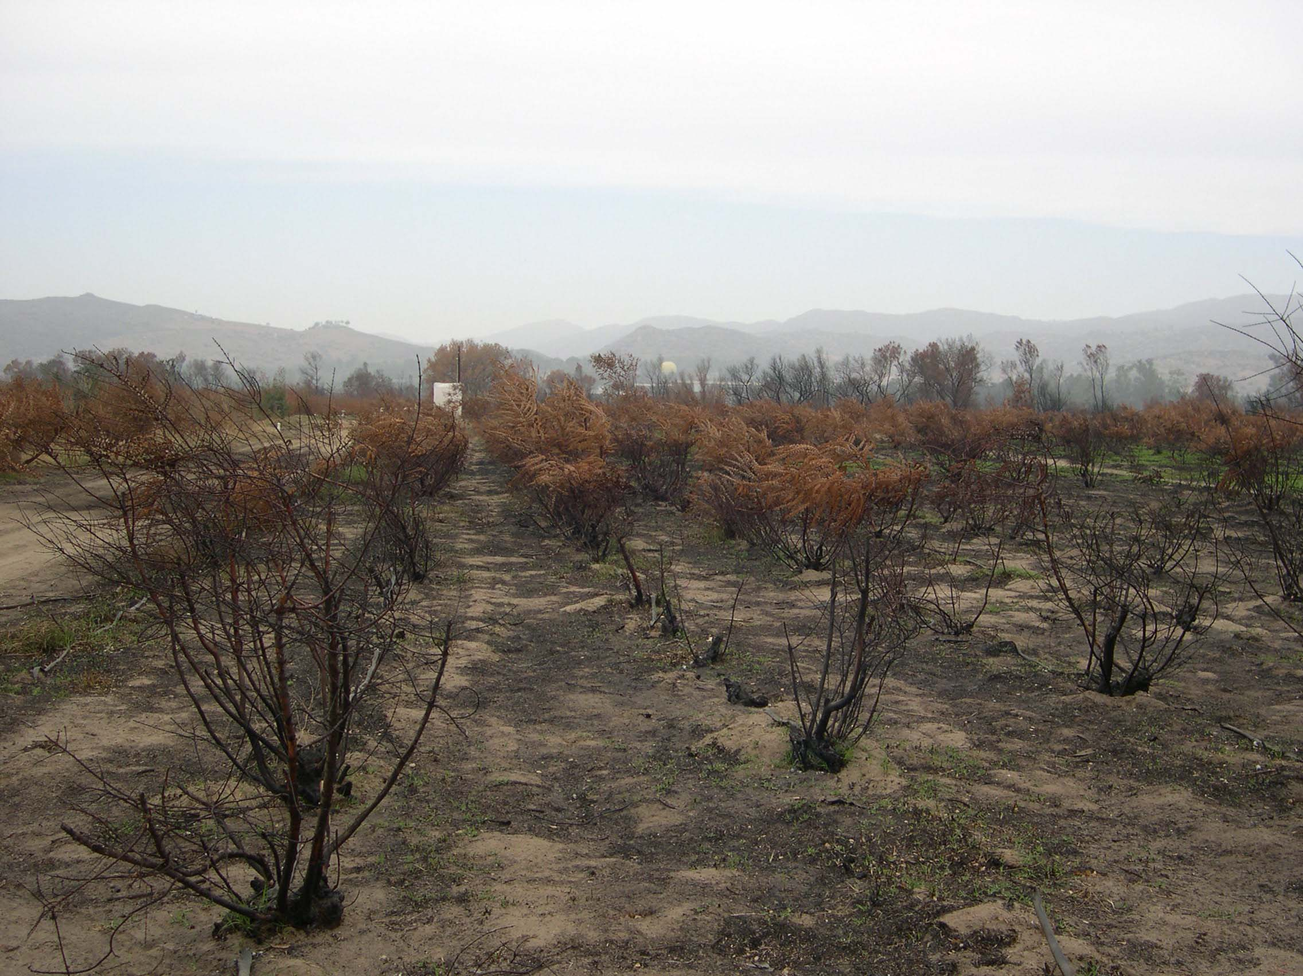

Burned Palms from the Rice Canyon fire

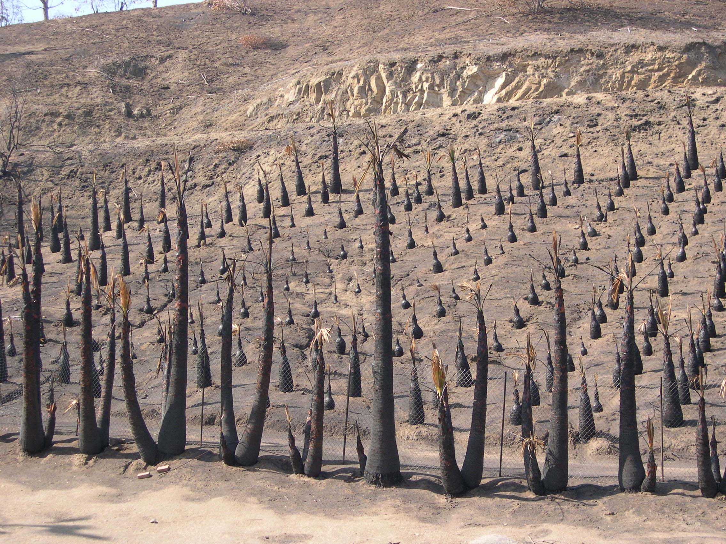
Wildfire outreach and education program

UCCE San Diego County, Floriculture Farm Advisor
The following new ANR publication is now available from Communication Services:
Monitoring Soil Moisture for Irrigation Water Management
Monitoring soil moisture is an alternate method to water-based balance methods of managing irrigation water. Using this method you can “see” what is going on in the soil and determine answers to some key irrigation management questions.
•Did enough water infiltrate the soil?
•Is too much water being applied?
•What is the water uptake pattern of the roots?
•When should irrigation take place?
•What was the depth reached by the irrigation?
Includes 24 figures and 7 tables, metric conversions, and an appendix of typical root depths.

21635 $25.00
http://anrcatalog.ucdavis.edu/InOrder/Shop/ItemDetails.asp?ItemNo=21635

New ANR Publications

• Is too much water being applied?
• What is the water uptake pattern of the roots?
• When should irrigation take place?
• What was the depth reached by the irrigation?
Includes 24 figures and 7 tables, metric conversions, and an appendix of typical root depths.
21635 $25.00
http://anrcatalog.ucdavis.edu/InOrder/Shop/ItemDetails.asp?ItemNo=21635

334 Via Vera Cruz, Suite 152
San Diego, CA. 92078

Phone:
760-752-4715

E-Mail:
jabethke@ucdavis.edu

New for 2008 from Ag Weights and Measures

Respirator Regulations

New respirator regulations for employees handling pesticides take effect on January 1, 2008. Listed below is a summary of the primary changes to the regulation, for more detail on what your company may need to do to meet these requirements, see our handout on our website at www.sdcawm.org. If you still have questions, you may contact your pesticide inspector at (858) 694-8980.

Changes in Summary:

• Medical Evaluation Form - A medical evaluation form will need to be completed and reviewed by a medical provider for all employees required to wear respirators by label or their employers. This evaluation form is completed confidentially by the employee and mailed directly to the medical provider. If needed a confidential reader must be provided to the employee to aid in completing the questionnaire.
• Written respirator program - must be established. The program should be comprehensive and cover all aspects of respirator use including storage, changing of filters, replacement respirators, etc.
• Fit Testing - Employees must be fit tested by using appropriately equipped respirator that can measure the pressure within the face piece or by other approved fit testing methods as listed in the regulation.
• Filtering face pieces - (resemble dusk masks but are NIOSH approved) also have requirements for use, which may include a medical evaluation and a written program.
• Voluntary Usage - Voluntary use of respirators (respirators provided by employer but not required by the label or employer to be worn) will require at a minimum posting of a document concerning respiratory protection and limitations on respirator use.

Operator Identification Numbers

Operator Identification Numbers (the form that allows use and purchase of agricultural chemicals for crop production) will be renewed this year and will have an expiration date of 2010. This form will be mailed out the first week of December. Please check your form when you receive it, to make sure contact information, acreage and crops are correct. Please call (858) 694-8980 if you need to make any changes. The form must be provided to your dealer before the purchase of agricultural chemicals. Those companies that have not had any pesticide activity in the last 3 years will not receive an Operator Identification Number by mail. Those companies will have the option of renewing in person after contacting their pesticide inspector.

Happy Holidays from the Department of Agriculture Weights and Measures.

Simone Hardy

Mexican Fruit Fly Quarantine

See the pest alert at the following web site:

http://groups.ucanr.org/farmgt/files/44558.pdf

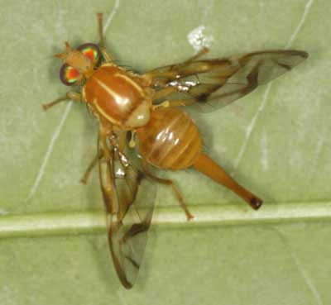
Mexican Fruit Fly
creatures.ifas.ufl.edu

We’re on the Web!
See us at:
www.cesandiego.ucdavis.edu/

