UCCE San Diego County, Floriculture & Nursery Farm Advisor
760-752-4715
bethke@ucr.edu
Floriculture & Nursery
News & Notes


January 2007
Volume 2, Issue 1
The IR-4 Project (Inter-Regional Project) is a program largely funded by the U.S Department of Agriculture (USDA) and the State Agriculture Experiment Stations (SAES), and its mission is to provide registration support for conventional crop protection chemicals and biopesticides on minor use crops, which include ornamental horticulture greenhouses and nurseries, landscape, Christmas tree farms, sod farms and interiorscapes.
2007 Ornamental Horticulture Survey
Every year, IR4 prioritizes the following year's research program at an Annual Ornamental Horticulture Workshop. IR4 invites you to help focus research questions in ornamentals horticulture by answering a few questions about the diseases, insects, and weeds that impact your business the most. Please take the time to get involved and fill out this brief survey form. See the following web site:
http://www.ir4.rutgers.edu/ornamental/Survey/

334 Via Vera Cruz, Suite 152
San Diego, CA. 92078

Phone:
760-752-4715

E-Mail:
bethke@ucr.edu

Society of American Florists

Pest Management Conference 2007
February 22-24
Portland Doubletree Lloyd Center
Portland, OR

Threatening Pests and Diseases
In my last newsletter I mentioned the potential of Japanese dodder (Cuscuta japonica) making it to San Diego County. It is a threat that we should be looking for so that we can eliminate it immediately because infestations can completely engulf host plants draping to the ground potentially killing the plant. However, I was asked a few important questions about it that I have answers for, and I thought I’d pass them along. First, Japanese Dodder is in Los Angeles County, so it’s not far away. Secondly, Dodder is common in southern CA, but our native version is closely associated with CA pepper trees and native chaparral, and it has a thinner strand than Japanese Dodder, which is described as about the diameter of a spaghetti noodle. In addition, our native dodder is flaming yellow to orange. Whereas, Japanese Dodder is yellow to pale yellow in color. Japanese dodder was found for the first time in California in the summer of 2004. For more information about Japanese Dodder, see the following web site:
http://www.co.contra-costa.ca.us/depart/agriculture/dodder.html

New Item for the Newsletter: Pesticide Regulation
In 2007, I hope to add a new section in my newsletter. It is everyone’s goal, including the Ag Commissioners office, that everyone complies with the laws as they are passed, changed, and interpreted on a yearly basis. Frequently, when I am giving a presentation across the state, someone will ask me a question about the interpretation of a new law because they have just been dinged. In one of last year’s newsletters I discussed at least one of those laws (eye wash bottles and their proximity). The Ag Commissioner’s office is going to cooperate with us by informing us of the issues that they are most concerned with in the ornamental horticulture industry. Let’s improve our compliance!

UCCE San Diego County, Floriculture Farm Advisor

Threatening Pests and Diseases, Cont.
The latest pest that we should all be looking for is the red palm mite. The Red palm mite, Raoiella indica Hirst (Acari: Tenuipalpidae) is a tenuipalpid or a thread footed mite. Thread footed mites are very small and can be moved easily by workers brushing up against infested foliage. Since they are so small, infestations are easily ignored until they are causing significant damage. The red palm mite is a pest of coconut, areca palm, and date palms in Egypt, India, Iran, Israel, Mauritius, Pakistan, Philippines, Sri Lanka, Sudan, and it is considered an international quarantine pest. It is quite serious. Recently the mite has reached the Caribbean Islands and has spread rapidly. Once pests like this reach the Caribbean, they eventually reach Florida where many of our palms originate. Hence, we should be on the lookout for it here so when it arrives we can nip it in the bud so to speak.
The red palm mite is bright red with long setae or hairs. All life stages, including the eggs, are red, and adult females often exhibit black patches across their backs. The red palm mite can be distinguished from spider mites (Tetranychidae) by the red color, long setae and flattened bodies (see photo in side bar). They prefer the undersides of leaves and are in dense groups that can be visible with the naked eye. Many white cast skins of immature stages may accompany the red mites. High mite densities cause localized yellowing of the leaves followed by tissue necrosis.
For more information about the red palm mite, see the following web site:
http://www.doacs.state.fl.us/pi/enpp/ento/r.indica.html

334 Via Vera Cruz, Suite 152
San Diego, CA. 92078

Phone:
760-752-4715

E-Mail:
bethke@ucr.edu

Red Palm Mite

See the pest alert at the following web site:

http://www.doacs.state.fl.us/pi/enpp/ento/r.indica.html

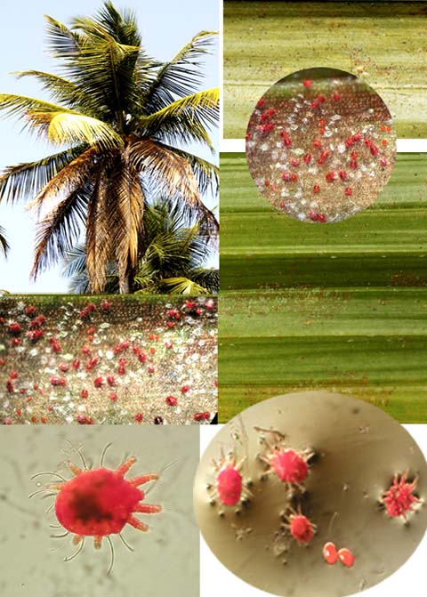

Recent ANR Publications

The following new ANR publications are now available from Communication Services:

Weeds of California and Other Western States
Joseph M. DiTomaso, Evelyn A. Healy

This encyclopedic yet easy-to-use guide covers 262 individual entries, including a full description of 451 species and another 361 plants compared as similar species, representing 63 plant families. Features of this guide include:
13 shortcut identification tables for groups that share similar, unusual, or relatively uncommon characteristics
2 grass identification keys - a key to all characteristics including inflorescences and reproductive parts and a key to vegetative characteristics only
67 tables comparing important characteristics of difficult-to-distinguish weedy species
Color photos of over 700 weeds including seeds, seedlings, flowers, and mature plants
CD of all of the photographs from the book suitable for use in PowerPoint presentations – over 3000 images!
2 volumes. 848 pp. 912 pp. 3488
$100.00
http://anrcatalog.ucdavis.edu/InOrder/Shop/ItemDetails.asp?ItemNo=3488

New Free Publications Recently
Posted to the Online Catalog

8180 Agricultural Biotechnology in California: Safety of Genetically Engineered Food
http://anrcatalog.ucdavis.edu/InOrder/Shop/ItemDetails.asp?ItemNo=8180

8200 Conservation Tillage and Weed Management
http://anrcatalog.ucdavis.edu/InOrder/Shop/ItemDetails.asp?ItemNo=8200

State and Federal Approach to Control of Nonpoint Sources of Pollution
http://anrcatalog.ucdavis.edu/InOrder/Shop/ItemDetails.asp?ItemNo=8203

Recently Updated Pest Note

7483 House Mouse
http://anrcatalog.ucdavis.edu/InOrder/Shop/ItemDetails.asp?ItemNo=7483

And remember, you can always find out what's new by pointing your browser to
http://anrcatalog.ucdavis.edu and clicking on "New Additions"

We’re on the Web!
See us at:
www.cesandiego.ucdavis.edu/

