UCCE San Diego County, Floriculture & Nursery Farm Advisor
760-752-4715
bethke@ucr.edu
Floriculture & Nursery
News & Notes


January 2008
Volume 3, Issue 1
Back in November I attended an afternoon meeting at the Farm Bureau entitled ‘Phytophthora ramorum in Nurseries: A Workshop for Retail, Wholesale, and Production Nursery Representatives’. The workshop was presented by the San Diego County Agricultural commissioner’s office, the California Oak Mortality Task Force (COMTF), the CDFA, the USDA, the CANGC, and UCCE. Unfortunately, it was poorly attended. I know that sometimes these workshops are not related to the kind of plants you grow or the work that you do because this industry is so diverse, but this issue is not going away and may affect you down the road. Indeed, you may not be aware of some of the restrictions or the recent occurrences in the county, so I thought I’d try to summarize them herein.
There is a good web site that covers much of what was covered in the workshop plus much more, http://nature.berkeley.edu/comtf/.
The first portion of the workshop was the history, description, and symptoms of Phytophthora ramorum. It was certainly meant for those that were unfamiliar with the problem, but it was very thorough and informative.
The next 45 minutes was very interesting, and if you are a nursery growing a regulated host or associated plant (HAP) (see the following site: http://www.aphis.usda.gov/plant_health/plant_pest_info/pram/downloads/pdf_files/usdaprlist.pdf), it could have been you. The list of hosts and related plants is long and many of the plants on the list may surprise you. I understand from the workshop that those growing hosts have been notified, so if you haven’t been, you should be aware.
Karen Suslow From Hines Horticulture discussed a draft form of the ‘Recommended Industry Best Management Practices (BMP) for the Prevention of P. ramorum Introduction or Establishment in Nursery Operations’. It is an industry recommended BMP for growers of host plants and consists of biosecurity guidelines for an effective monitoring plan to reduce the risks associated with P. ramorum. It is a work in progress, but a fine document worth looking into.
Unfortunately, Karen discussed what happened when Hines recently experienced a single positive find in their nursery in San Diego County, and it triggered regulatory action by APHIS and the CDFA. In spite of the fact that the positive find was a false positive, Hines incurred a significant loss. Indeed, their customers notified by a trace forward destroyed the product they were shipped, just in case. They did not want to be on the hit list at all.
That act by receiving customers was cautious and prudent, but from a scientific standpoint, the action by regulatory agencies was not (acting on a single positive find that in all likelihood is a false positive, without confirming that it is truly a positive find). That issue is being discussed among commodity groups and (Cont. next page)

334 Via Vera Cruz, Suite 152
San Diego, CA. 92078

Phone:
760-752-4715

E-Mail:
jabethke@ucdavis.edu

Poomacha Fire Damage in San Pasqual

Baby Blue Eucalyptus is gone

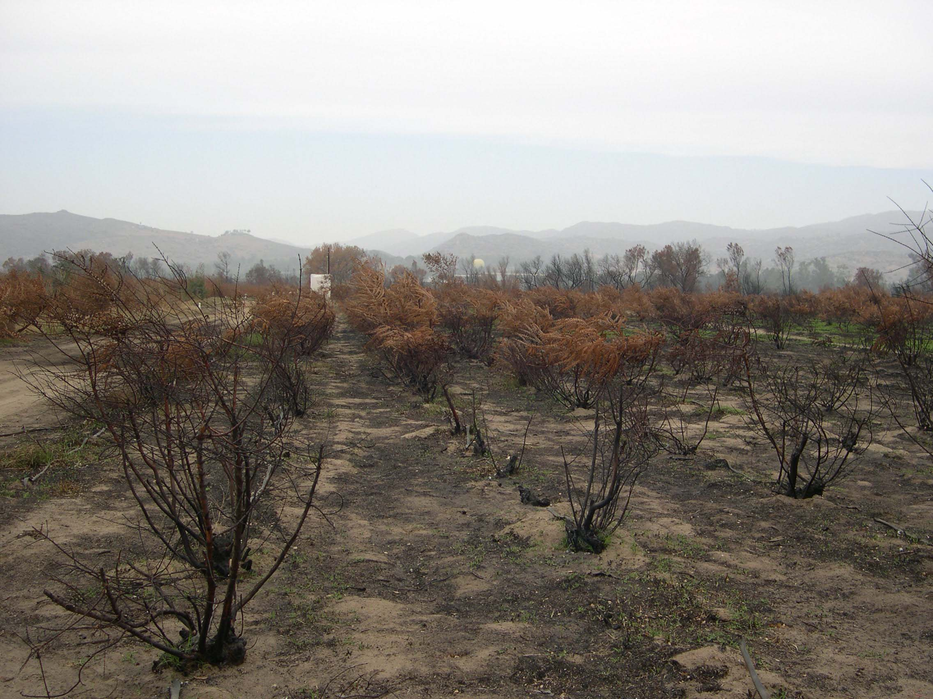

Burned Palms from the Rice Canyon fire

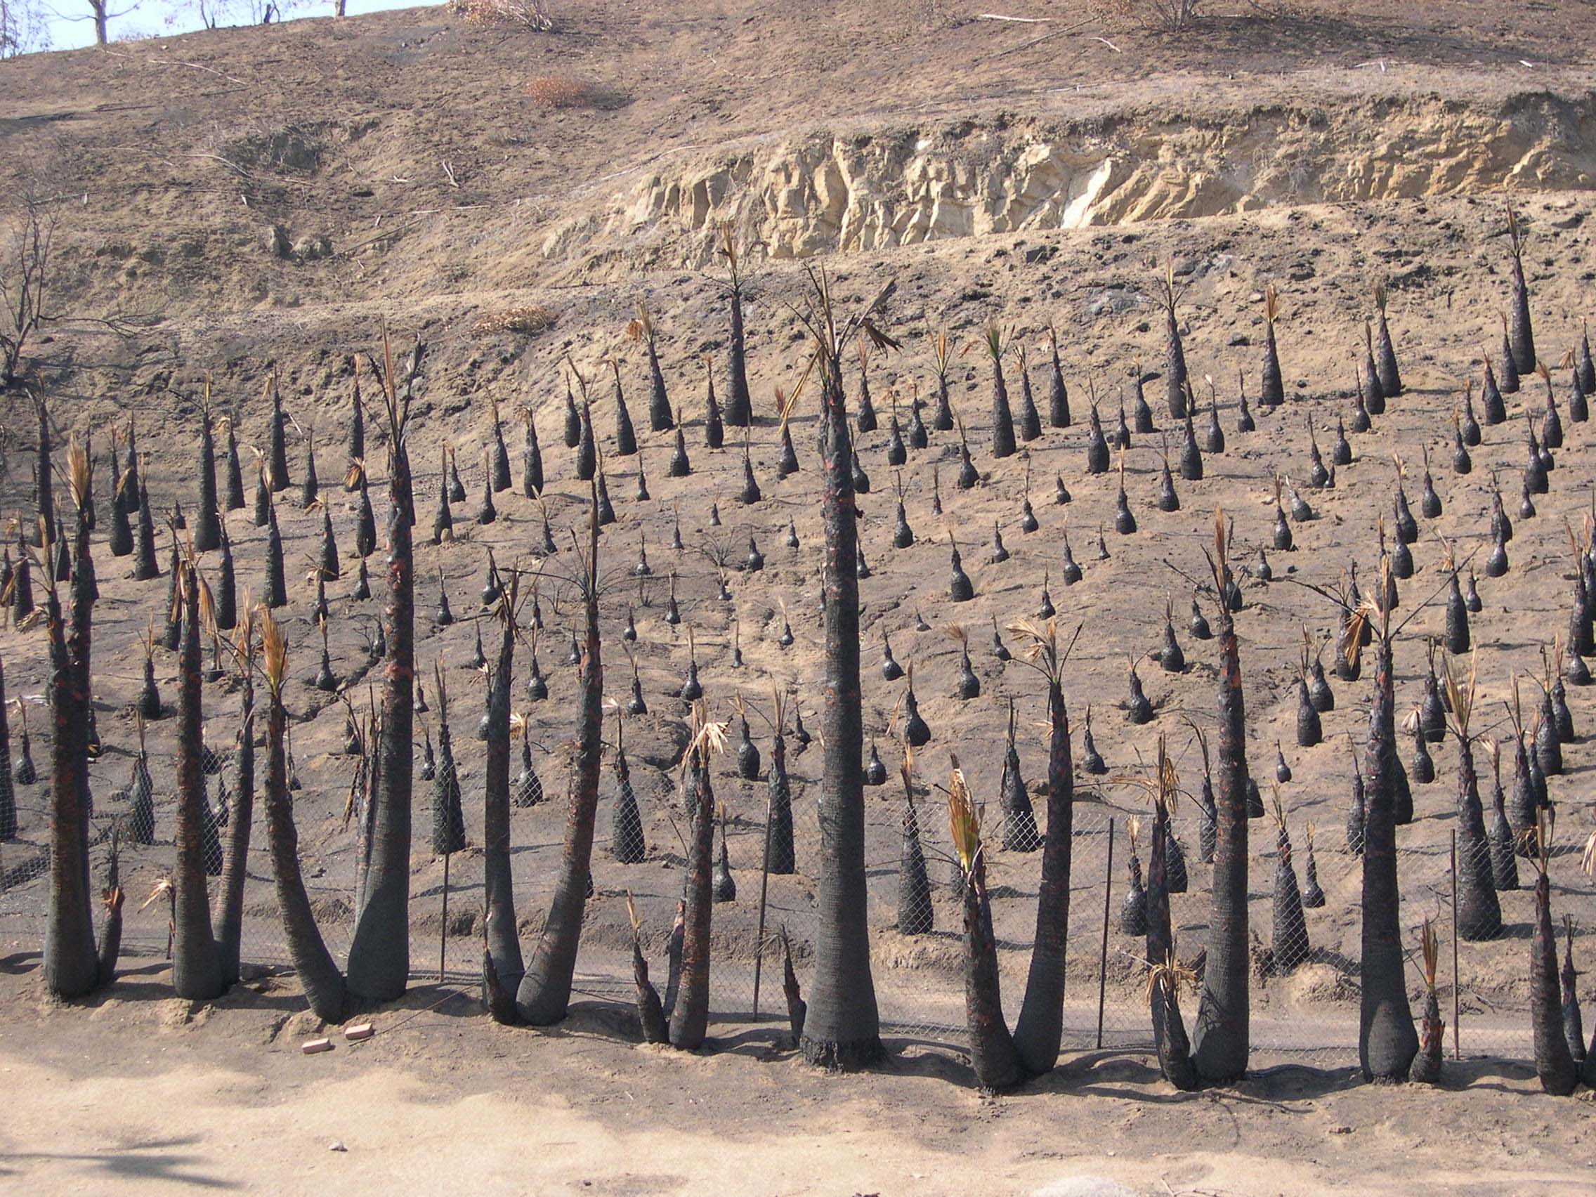
Oak Mortality Task Force Meeting (SOD)

UCCE San Diego County, Floriculture Farm Advisor
Oak Mortality Task Force Meeting (SOD) Cont.

regulatory agencies as I write, but your industry needs to be involved, and the more you are informed of these issues, the more prepared you will be to respond. That’s why attending some of these workshops can be important because you can be in a better position to take proactive action rather than reactive action.
Karen was followed by Katie Filippini from the CDFA, who outlined the federal and state regulations

regarding the sale and distribution of P. ramorum hosts and associated plants, and the required compliance agreements.
Lastly, there was a summary of the most recent research on P. ramorum and its hosts, which included a demonstration of an ELISA kit that detects Phytophthora.
It was a lot to pack into one afternoon, but very informative.

334 Via Vera Cruz, Suite 152
San Diego, CA. 92078

Phone:
760-752-4715

E-Mail:
jabethke@ucdavis.edu

Veriflora: Certified Sustainably Grown

The San Diego County Flower and Plant Association sponsored another meeting that I attended last month. It was an introduction to Veriflora (http://www.veriflora.com/), a sustainability certification program for fresh cut flowers and potted plants. You will note the use of a few buzzwords like sustainable and certified.
Veriflora was also introduced by Dr. Michael Parrella last year in the CORF ABCs of IPM meetings. The growers in the audiences were convinced that the idea was timely and needed, and they were quite accepting. There were, however, many questions posed by the growers concerning the qualifications and the march toward sustainability in the ornamental industry. Since there seems to be a great number of hurdles to certification and many questions about it, I thought I’d start a little dialog in the next few newsletters that describe some of those hurdles. Some of the questions asked that I will be entertaining are the following: 1) What is Veriflora, Science Certification Systems, ANSI, Certification, Quality, etc.? 2) What does the ban on the World Health Organization chemicals in the 1a and 1b categories mean to you? 3) Who will enforce the Veriflora Logo? 4) Who makes the decisions about what is sustainable? 5) What are the most difficult qualifications?
Obviously, these are not the only questions that need answering and I’d like to know what other things you have heard that you are concerned about so that I can address them. Let me know what you think and let’s discuss the issue.

Mexican Fruit Fly Quarantine

See the pest alert at the following web site:

http://groups.ucanr.org/farmgt/files/44558.pdf

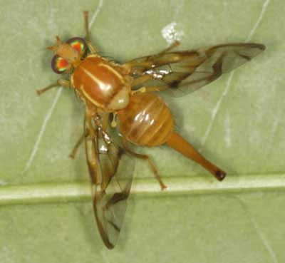
Mexican Fruit Fly
creatures.ifas.ufl.edu

The Resource conservation District partnered with the California Department of Education to create the San Diego Regional School Garden Resource Center several years ago (see the following web site http://www.rcdsandiego.org/programs/schoolgardens.html). Many local schools have received state grants to grow gardens for educational purposes, and the teachers use the garden as a tool to teach nutrition, agriculture, nature, science, math, etc. To prepare the teachers, the District will hold its Ninth Annual San Diego Regional School Garden and Nutrition Conference on Saturday April 19th at the Del Mar Fairgrounds, where I will be speaking to teachers on how to use insects as educational tools in their classrooms. Altman Plants has generously donated a great number of bedding plants to the local school gardens, but the Resource center has increased the number of participating schools significantly. Therefore, they are seeking more donations. If you are interested in donating plants, please contact Vince Lazaneo at 858-694-2849 or email him at vflazaneo@ucdavis.edu.

San Diego Regional School Garden Resource Center

We’re on the Web!
See us at:
www.cesandiego.ucdavis.edu/

