Volume 7, No. 1

Spring 2009

Editor’s Note:

Please let us know if your mailing address has changed, or if you would like to add someone else to the mailing list. Call or e-mail the farm advisor in the county where you live. Phone numbers and e-mail addresses can be found in the right column.

Please also let us know if there are specific topics that you would like addressed in subtropical crop production. Copies of Topics in Subtropics may also be downloaded from the county Cooperative Extension websites.

Neil O’Connell
Editor of this issue

Topic Page

Avocado Research in Ventura County 1

Laurel Wilt Disease Conference and 2
Tour in Florida and Georgia

Managing Insecticide Resistance will be 6
Key to the Future of Effective Citrus
Pest Management

Smart Sprayers Make Sense 8



Farm Advisors

Gary Bender – Subtropical Horticulture, San Diego
Phone: (760) 752-4711
Email: gsbender@ucdavis.edu
Website: http://cesandiego.ucdavis.edu

Mary Bianchi – Horticulture/Water Management, San Luis Obispo
Phone: (805) 781-5949
Email: mlbianchi@ucdavis.edu
Website: http://cesanluisobispo.ucdavis.edu

Ben Faber – Subtropical Horticulture, Ventura/Santa Barbara
Phone: (805) 645-1462
Email: bafaber@ucdavis.edu
Website: http://ceventura.ucdavis.edu

Neil O’Connell – Citrus/Avocado, Tulare
Phone: (559) 685-3309 ext 212
Email : nvoconnell@ucdavis.edu
Website: http://cetulare.ucdavis.edu

Craig Kallsen – Subtropical Horticulture & Pistachios, Kern
Phone: (661) 868-6221
Email : cekallsen@ucdavis.edu
Website: http://cekern.ucdavis.edu

Eta Takele – Area Ag Economics Advisor
Phone: (951) 683-6491, ext 243
Email: ettakele@ucdavis.edu
Website: http://ceriverside.ucdavis.edu

Jeanette Sutherlin for Mark Freeman – Citrus & Nut Crops, Fresno/Madera
Phone: (559) 456-7285
Email : mwfreeman@ucdavis.edu
Website: http://cefresno.ucdavis.edu

Avocado Research in Ventura County

In 1882 Mexican avocado seedlings were planted on N. Ventura Avenue. By 1942 there were 231 acres in the county, but by then there was a hodge podge of over 100 named varieties. By 1954 there were nearly 2,000 acres and most of the commercial orchards were planted to ‘Fuerte’ variety with some ‘McArthur’ thrown in for good measure. Much of this search for the ideal commercial variety was driven by growers, but there was a certain amount of research carried out by UC Cooperative Extension Farm Advisors and the University of California, Citrus Experiment Station at Riverside. There wasn’t much that could be done about things like fire, freeze, flood and heat waves that burned off the flowers, and that was all that seemed to affect the
trees at that time. The first line of research that really

brought the force of the University of California to the industry was the appearance of “avocado decline.” This was the slow decline of trees, losing leaves, thinning canopies and dying roots. The cause of the decline was identified as a fungus, Phytophthora cinnamomi, avocado root rot. It would take another 50 years of research to identify a comprehensive program of irrigation management, mulch, mounding, gypsum, chemicals and clonal rootstocks to finally allay growers’ fears of this disease which is widespread in avocado growing areas worldwide. The selection of rootstocks that were tolerant of the disease was started in the 50’s by George Zentmyer at UC Riverside and continues to this day, and now has been broadened to make sure they are also tolerant of such things as salinity and another disease, crown rot, which is another fungus related to root rot.

The acreage in Ventura County today hovers around 17,000, with many new plantings. Since the early days, the research we do has been predominantly in collaboration with growers - research onsite in real-life conditions. Grower researchers are incredibly important to the University’s work because they do what they say they will do and don’t do what they say they won’t do. It’s incredibly frustrating to have a research plot that gets picked or sprayed when it shouldn’t be and finding a good collaborator is invaluable to the research project. The number of growers who have worked on research are too numerous to name, but we are all thankful for the work they have done with the numerous folks from Cooperative Extension and UC Riverside.

Since the 50’s we have had a wave of new pests come into the avocados – six-spotted mite, avocado brown mite, greenhouse thrips, persea mite, avocado thrips, neohydatothrips – and in each case, University research has found an answer to the problem. Often it has been a biological control agent which meant for years that avocados were one of the few unsprayed crops in California. In some cases the solution has been as simple as size picking to reduce fruit clusters, as in the control of greenhouse thrips or managing nitrogen fertilization in a different way, as in the case of persea mite.

Extensive work has also been done on diseases, such as oak root fungus, sun blotch, stem blight, and crown rot, and in most cases we have found solutions to these problems. Other management practices we have evaluated have been irrigation, fertilization, girdling, stump control, pruning and pollination. These studies have often been in collaboration with people at UC Riverside, but more often it has been the County office staff that has initiated and carried out the work.

Members of the University and CDFA (California Department of Food and Agriculture) are now looking at a new disease of avocado that is currently in the southeast. It is called laurel wilt and kills members of the laurel family of which avocado is a member. It also could go to a common tree found along the coast from San Diego to the Oregon border, bay laurel. This disease could easily get into our orchards if infected plants or wood are brought into the state. Several members of UC are going to Florida and Georgia to see the infected trees. One reason for going to see this disease is to be able to identify it, but also to see if we can put in place regulatory measures to prevent the further spread of the disease.

We still can’t control the weather, but Ventura County growers and Cooperative Extension will continue to work on those things we can control.

Laurel Wilt Disease Conference and Tour in Florida and Georgia

On February 22, Gary Bender and Ben Faber traveled to Orlando, FL to view laurel wilt disease of avocado, Raffaelea lauricola, spread by the Asian ambrosia beetle, Xyleborus glabratus. Akif Eskalen from UC Riverside was also with us. We met with Jonathan Crane of University of Florida, Tropical Research and Extension Center. We were also accompanied by Extension Agents Ryan Atwood and Linda Seals. Orlando is toward the southern edge of the disease that has spread from Georgia, up to South Carolina and into Florida. It has spread to within 100 miles of Miami. The insect was first noticed at the Savannah shipping terminal in 2002. The insect quite possibly came in on wood packing boxes that were infested. The disease was not identified until 2004, initially being confused as salt injury or waterlogging damage on red bay (Persea borbonia). The disease initially spread through the native red bay forests, killing other laurel family members, such as sassafras, pondspice and pondberry. In Florida, along with the spread in the native forest, it has also spread to backyard avocado trees. USDA and State forestry officials from South Carolina, Georgia and Florida estimate the natural spread of the disease to be 17-20 miles per year, but human intervention through movement of infested firewood has accelerated the disease distribution (see distribution map at end). The insect carrying the fungal disease can fly and with its small size can easily be wind-borne. It spends much of its lifecycle in the wood. There are notices in the three-state areas about not moving firewood, but there is little enforcement. Nurseries are not restricted in their movement of plants in the laurel family, other than by standard nursery sanitation criteria. In California, hosts include avocado, California native bay laurel (Umbellularia californica), found in coastal California through Oregon, and in the landscape tree camphor
(Cinnamomum camphora).

We traveled in the Orlando area and saw trees that had rapidly died from the disease (see images). It appears that only a single beetle invading the tree is needed to cause the disease. It bores into the xylem, spreading the fungus. The fungus clogs the xylem and trees can collapse in as little as 3 months. It is thought that the fungus can spread to neighboring trees through root grafts. In a number of the dead trees we saw numerous entry and exit holes, indicating that more than one beetle had attacked the trees. The Orlando area is too cold for commercial orchards, but there are backyard trees. Tree collapse looks very similar to freeze damage and it was not hard to identify collapsed backyard trees.

From Orlando we went to Savannah for the Laurel Wilt Conference. Just prior to the meeting the Laurel Wilt Workgroup met. This is a group of 18 USDA, State Foresters and University of Florida faculty headed up by Randy Ploetz, plant pathologist at University of Florida. Ploetz and several other faculty, including Jorge Peña, Jason Smith and Jonathan Crane, have been looking into the pest/disease complex with money from the Florida Avocado Growers Association. The group is in the process of seeking a USDA Specialty Crops grant to further study laurel wilt.

Several of their trials have shown some degree of variability in disease susceptibility in avocado. At this point, they have not identified an effective insecticide or fungicide as a control. They have identified manuka oil as a successful attractant for the ambrosia beetle, but a wounded tree acts as an attractant, as well. Work is continuing in this area and we have been in discussions with members of the workgroup on better control tactics.

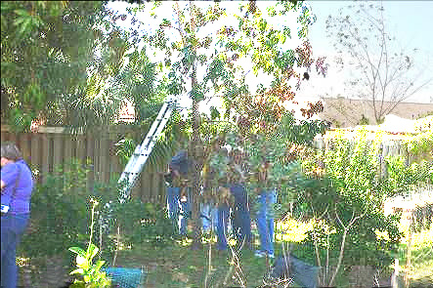
At the conference we went on a tour of affected forests and witnessed the loss of red bay and sassafras. Red bay is native to South Carolina south to Florida and east to Texas, and the disease could easily be spread throughout this area and possibly into Mexico. The US and State foresters who have been monitoring the spread of the disease were quite open in discussing the difficulty in containing the spread of the disease.

During the conference it was reported that the beetle could go to other non-laurel species such as Calychanthus floridus and Cercis Canadensis, which would substantially increase the range the insect could move (Steve Fraedrich, US Forest Service). In the southeast, the female beetles fly predominantly in the fall, but they have been trapped year round. They are
most attracted to red or blue sticky cards and much less so to yellow. The beetles have been trapped at heights
as high as 45 feet, so they can easily get into trees without their entrance holes being noticed. Wounded trees are also attractive to the beetles. Manuka oil seems to be the most attractive odor. (All five of these last comments were made by James Hanula, US Forest Service). Jason Smith (University of Florida) has found multiple genotypes of the Raffaelea fungus with different virulence to avocados. This also probably indicates that there have been multiple introductions of the fungus and beetle. Jorge Peña and others indicated that the disease has not been reported killing avocados in Asia and that quite possibly there are areas where the less virulent strains are found.

At this point it is mainly Florida that is doing avocado research on the disease and how to control both it and the beetle. The threat to avocados is world-wide and it would seem that Florida is where we should put resources to stopping this problem that could affect all avocado growers.

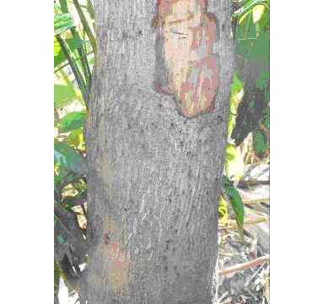

Vascular staining in avocado with beetle entry holes.

Avocado in process of collapse. In this case, single branches are dying.

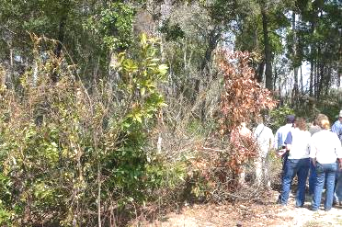
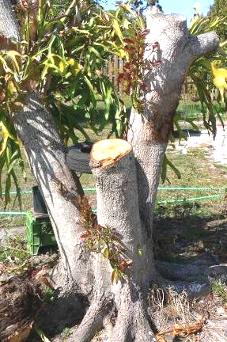
Red bay (P.borbonia) in collapse.

Avocado collapsed, one year old. New shoots will
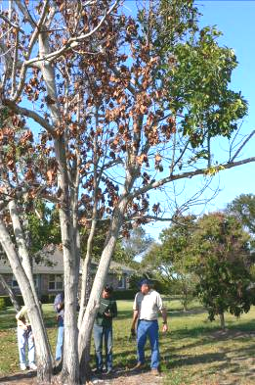
collapse.

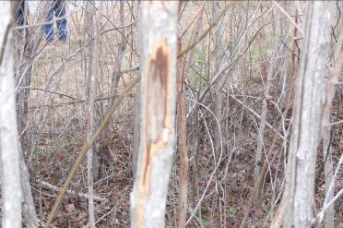

Sassafras (Sassafras albidum) in collapse.

Multi-trunked avocado in process of collapse.

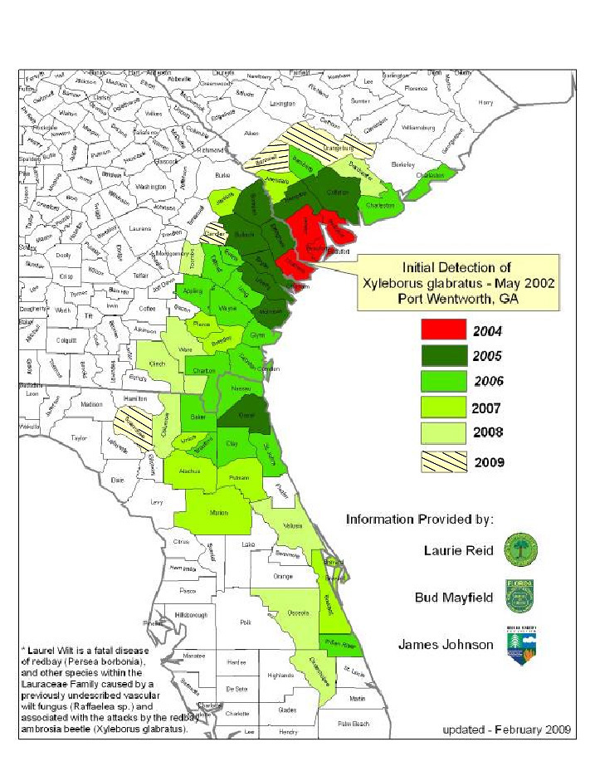
Distribution of Counties with Laurel Wilt Disease* Symptoms,
by Year of Initial Detection

Managing Insecticide Resistance Will Be Key to the Future of Effective Citrus Pest Management
Joseph G. Morse and Elizabeth E. Grafton-Cardwell

In California, we have a long history of citrus thrips and California red scale developing resistance to insecticides. When insecticides from the same class of chemistry (see Table 1 for insecticide classes) are used repeatedly or for long periods of time, insecticide resistance appears, and the first sign of resistance is a reduction in how long an insecticide controls a population. For example, when Cygon (dimethoate) was first used for citrus thrips control in 1962, thrips levels typically remained at very low levels for 6-8 weeks after treatment. In the early 1980’s, resistant citrus thrips populations were seen in some parts of the San Joaquin Valley and growers began to see moderate levels of live thrips 3-4 weeks after treatment and, in some cases, as early as 1-2 weeks following a spray (Morse & Brawner 1986). Similarly, in the early 1990’s, a number of populations of California red scale began to show resistance to broad-spectrum organophosphate (Lorsban and Supracide) and carbamate (Sevin) insecticides in the San Joaquin Valley (Grafton-Cardwell and Vehrs 1995, Grafton-Cardwell et al. 2001). Instead of these insecticides providing season-long control of California red scale, treatments only lasted one generation. As resistance increased, growers needed to treat for California red scale 2-3 times per season.

Citrus thrips resistance to dimethoate was followed by heavy use of Carzol and resistance to this insecticide appeared in the late 1980’s (Immaraju et al. 1989), which resulted in a Section 18 being obtained allowing the use of Baythroid for 6 years 1991-1996. Resistance of citrus thrips to pyrethroids such as Baythroid was seen as early as 1996 (Khan et al. 1998). Success was registered in 1998, and by the turn of the century, this insecticide was the main product used for citrus thrips control (Morse et al. 2001).

In 1998-1999, two insect growth regulators, Esteem and Applaud, were given emergency registration for control of California red scale (Grafton-Cardwell 1999) because of organophosphate and carbamate resistance. Esteem acts as a juvenile hormone mimic that inhibits egg hatch and metamorphosis into the adult stage (Ishaaya et al. 1994) and Applaud is a chitinase inhibitor that inhibits molting. Although both insecticides were later registered Esteem was shown to be more effective in controlling California red scale. Thus, Esteem rapidly became the most commonly used insecticide for control of California red scale (Grafton-Cardwell et al. 2006).

In the last several years, there have been reports of lessened control with Esteem and laboratory studies have confirmed that the early stages of resistance are starting to appear in California red scale (Grafton-Cardwell, unpublished data). Treatments of Esteem initially reduced California red scale for three years and growers are now reporting that Esteem reduces scale for only one year in some locations.

Restraint – the best resistance management tool. For both citrus thrips and California red scale, the number one tool in managing insecticide resistance is restraint. That is, do not overuse any one class of insecticide during a given period of time. As a basic resistance management practice, pest populations should be monitored carefully and treatments applied only when they are warranted. For example, if citrus thrips populations are low one week after petal fall, carefully consider whether a treatment is needed this year or consider using a different class of chemistry. Use a different class even though it doesn’t have as high efficacy (e.g., Veratran D) as other options (such as the spinosyns) that thrips have been exposed to more frequently. Low populations of California red scale might be maintained at low levels using Aphytis melinus releases, rather than using an insecticide, to avoid selecting for resistance. When treatments are scheduled, they should be applied carefully, i.e. with proper timing of the treatment and optimal spray coverage (see Citrus Pest Management Guidelines at http://www.ipm.ucdavis. edu/ PMG/selectnewpest. citrus.html) so as to extend the time before another treatment might be needed. For example, with careful spray timing and coverage, California red scale can be treated every second or third year. Growers should maximize biological control to the degree that is possible to reduce the number of insecticide treatments applied per season. This is accomplished by minimizing the use of broad-spectrum pesticides and/or by carefully timing such treatments. For example, spring is a critical period for biological control of many citrus pests and so broad-spectrum pyrethroids, organophosphates, carbamates, and neonicotinoids should be avoided during that period. A combination of soft pesticides and natural enemies provides longer term control than broad-spectrum insecticides.

When an insect develops resistance to one insecticide within a chemical class, it usually has resistance to all of the insecticides within that class (cross-resistance), whether they are exactly the same insecticide or a closely related insecticide. A large number of generic brands of abamectin and imidacloprid have become available in the last few years (Table 1). Be sure to study the table and recognize the trade names in relation to the chemical class to avoid treating in the same season with the same chemical or same chemical class.
Delegate, a new spinosyn. Delegate was registered for use on California citrus in 2007. Although it appears to be more effective against citrus thrips than Success (or Entrust, the organically approved formulation), it is in the same class of chemistry as Success. Cross-resistance is expected between Success and Delegate and possibly with Agri-Mek and other avermectins. Considering that many growers have been using Success since 1998, there is concern that resistance to this class of chemistry (the spinosyns) may appear in citrus thrips populations in the future. Thus, growers and pest control advisors should try not to use more than a single application of Delegate per year and if possible, should rotate to other insecticides to the degree that is possible so that Delegate is used only as much as every other year. Possible rotation insecticides include Veratran D, Agri-Mek (and generic avermectins), Movento (but see the discussion below), and possibly dimethoate, Carzol, Baythroid, or Danitol if resistance to one or more of these insecticides is not present or they haven’t been used in a particular grove for 3-5 years (i.e. try them some period of time after their last use to see if resistance has reverted; it is hard to generalize how well they will perform based on our limited experience to date – generally, one might expect to obtain fair control with a use once every 3-5 years if resistance has not reached high levels).

Movento, a new class of chemistry. Movento was registered in California in 2008 and is effective against California red scale and citrus thrips and suppressive against a number of other pests including citrus red mite, citrus leafminer, and aphids. It will be a very important product for future control of Asian citrus psyllid (as will Delegate), should that pest spread outside the current eradication area in southern California into commercial citrus. Thus, it is critical that growers and pest control advisors be conservative in using Movento during the coming years so that resistance does not develop in one or more of these pests. We suggest that growers use Movento primarily for California red scale control (unless they have a citrus thrips-Delegate resistance concern) and strongly suggest that Movento not be used more than once a year. This is critical because of Movento’s persistence and will be even more important should Asian citrus psyllid be present. With the beginnings of California red scale resistance to Esteem showing, growers should carefully consider the variety of options that are available for control of this insect including minimizing broad-spectrum pesticide use coupled with releases of Aphytis melinus, and use of chemicals such as Movento, Esteem, Applaud and oils on a rotational basis.
When Asian citrus psyllid moves into California citrus, we will have to be very careful to not overuse any one class of chemistry such as Movento, spinosyns, avermectins, pyrethroids, and neonicotinoids. Unfortunately, relatively few new classes of chemistry are coming to the marketplace and invasive pests such as Asian citrus psyllid may require increased pesticide use, making resistance management an important consideration in optimizing a pest management program.

References Cited

Grafton-Cardwell, E, E. 1999. Section 18s for California red scale control. Citrograph 84: 8, 10.

Grafton-Cardwell, E. E. and S. L. C. Vehrs. 1995. Monitoring for organophosphate- and carbamate-resistant armored scale (Homoptera: Diaspididae) in San Joaquin Valley citrus. Journal of Economic Entomology 88: 495-504.

Grafton-Cardwell, E. E., J. E. Lee, J. R. Stewart, and K. D. Olsen. 2006. Role of two insect growth regulators in integrated pest management of citrus scales. Journal of Economic Entomology 99: 733-744.

Grafton-Cardwell, E., Y. Ouyang, R. Striggow, and S. Vehrs. 2001. Armored scale insecticide resistance challenges San Joaquin Valley citrus growers. California Agriculture 55: 20-25.

Immaraju, J. A., J. G. Morse, and D. J. Kersten. 1989. Citrus thrips (Thysanoptera: Thripidae) pesticide resistance in the Coachella and San Joaquin Valleys of California. J. Econ. Entomol. 82: 374-380.

Ishaaya, I., and A. R. Horowitz. 1995. Pyriproxyfen, a novel insect growth-regulator for controlling whiteflies - mechanisms and resistance management. Pesticide Science 43: 227-232.

Khan, I. and J. G. Morse. 1998. Citrus thrips (Thysanoptera: Thripidae) resistance monitoring in California. Journal of Economic Entomology 91: 361-366.

Morse, J. G. and O. L. Brawner. 1986. Toxicity of pesticides to Scirtothrips citri (Thysanoptera: Thripidae) and implications to resistance management Journal of Economic Entomology 79: 565-570.

Morse, J. G., E. E. Grafton-Cardwell, and A. A Urena. 2001. Management options for citrus thrips in the San Joaquin Valley. Citrograph 86: 4-5, 12.

Table 1. Insecticides used on California citrus, classified by mode of action (In part from IRAC [Insecticide Resistance Action Committee], www.irac-online.org).

Class | Primary target site | Chemical sub-group or [exemplifying active ingredient] | Insecticides in the class
1A | Acetylcholine esterase inhibitors | Carbamates | carbaryl (Sevin), methomyl (Lannate), formetanate hydrochloride (Carzol)
1B | Acetylcholine esterase inhibitors | Organophosphates | chlorpyrifos (Lorsban), methidathion (Supracide), dimethoate (Cygon), naled (Dibrom), malathion, azinphosmethyl (Guthion), phosmet (Imidan)
3 | Sodium channel modulators | Pyrethroids, Pyrethrins, DDT | cyfluthrin (Baythroid), fenpropathrin (Danitol), pyrethrins & pyrethrum
4 | Nicotinic acetylcholine receptor agonists / antagonists | Neonicotinoids | systemic and foliar imidacloprid (Admire Pro, Provado and generics such as Advise, Alias, Couraze, Imida E-AG, Macho, Montana, Nuprid, Pasada, Prey and Widow), acetamiprid (Assail)
5 | Nicotinic acetylcholine receptor agonists (not group 4) | Spinosyns | spinosad (Success/Entrust), spinetoram (Delegate)
6 | Chloride channel activators | Avermectins, milbemectins | abamectin (Agri-Mek and generics such as Abacus, Abamectin E-AG, Abba, Epi-Mek, Reaper, Temprano, Zoro) and Clinch ant bait
7C | Juvenile hormone mimics | pyriproxyfen | pyriproxyfen (Esteem)
16 | Inhibitors of chitin biosynthesis, type 1, Homopteran | buprofezin | buprofezin (Applaud)
23 | Inhibitors of lipid synthesis | Tetronic acid derivatives | spirodiclofen (Envidor), spirotetramat (Movento)
-- | Unclassified | Oils | Various petroleum oils (415, 440, 455, 470 narrow-range oils)
-- | Unclassified | Sulfur | Various sulfur formulations

Smart Sprayers Make Sense
Franz Niederholzer, UC Farm Advisor,
Sutter/Yuba Counties

It costs a lot to farm tree crops. It will probably cost more before (if?) it ever eases up. So, how can you keep investing in your orchard to maintain yield and income and still make a living? Here are my answers to that question:

- Consistently raise a large, high quality crop
- Protect and maintain orchard health
- Produce what the market wants
- Be efficient

Towards these goals, there is a tool that will reduce your pesticide/foliar fertilizer costs by an average of 20% without changing crop protection or spray coverage. It’s a sprayer with sensors – a “smart sprayer”. If you aren’t thinking about buying one, you should.

How smart sprayers work. Smart sprayers “look” for trees with sonar or laser “eyes”, and turn on only the nozzles when there is a target (the tree) to spray. They are available as after-market add-ons or built into the
sprayer at the plant. Some models can only activate/deactivate one side of the sprayer. These models perform best in uniform young orchards with regular gaps between the trees. Others models have two or three “eyes” per side. Each eye controls half or a third of the nozzles on a side. The multiple eye models cost more, but are more flexible. They are the best units to have in an irregular mature orchard with replants, skips and/or shaded-out regions.

Smart sprayers save you money. Smart sprayers can save you around 20% on pesticide costs/acre compared to running the sprayer with all nozzles on. That number will go up or down depending on the orchard system. Hedgerow plantings should show less savings, especially if the nozzles are carefully set up for each particular block. Mature orchards with gaps between the trees or multiple replants should see an increase in savings. Significant savings should be seen in young plantings with gaps between each tree. Smart sprayers reduce your pesticide bill without reducing orchard pest protection. You spray your trees, not the orchard and everything therein. A recent study done at California State University, Chico projected a multiple-eye smart sprayer cost recovery to be 1-2 years for a 300 acre almond orchard. That’s on a $15,000 initial investment in an aftermarket addition of the smart sprayer “eyes” and control valves on an existing sprayer. How would that work for your farm? Here’s a rough estimate for almonds. An annual almond orchard pesticide bill can run around $250/acre. A 25% saving on that bill – the kind of savings that growers with smart sprayers report – is $62.50/acre/year. That number doesn’t include the diesel and time saved by stretching 5 acres/tank at 100 gpa into 6.25 acres/tank with the same coverage. That extra acreage in each tank could help come crunch time (at bloom, when wind is forecast, or when PHI is an issue).

Smart sprayers help your operation be sustainable. The first rule of drift management is “target the tree”. The smart sprayer does that for you – automatically. Off-target pesticides can drift or land on the orchard floor and be lost with irrigation or storm runoff. A smart sprayer is a cleaner sprayer.

A smart sprayer is also driver friendly. Using a smart sprayer gives the sprayer operator one less thing to worry about at the end of the row. It shuts off the nozzles automatically as you turn out of one row and then back on as you enter the next row. Note: It will spray telephone poles! The operator is free to drive, not multitask. Do you farm near roads? Smart sprayers help operators reduce spray drift near sensitive areas, and avoid spray drift fines.

Finally, more and more fruit and nut buyers are looking for evidence of “sustainable” practices. Keeping the customer happy is a key to successful business. If they want “sustainable” and you want good crop protection, a smart sprayer could be a solid answer.

Federal help in buying a Smart Sprayer. The 2008 EQIP program of the USDA Natural Resources Conservation Service (NRCS) provided cost share money for growers in the San Joaquin Valley to buy and use “precision pesticide/herbicide application technologies”—Smart Sprayers. The goal of this program was to reduce use of VOC emitting chemicals (Lorsban EC, etc.) by 20%. That program paid $30/acre for a maximum of 500 acres. Contact your local USDA NRCS office to see if a similar program is available in 2009.

Reality check. Smart sprayers are not perfect. They are more complicated than a conventional airblast sprayer. There are more electronic components to maintain and to repair. Specialized technical service costs money. If the problem can’t be fixed over the phone, you have to take the sprayer to the manufacturer or pay to have them come to you. However, to get you through an application, smart sprayers can go “dumb” with the flick of a switch. If your farming operation is technology averse anywhere from the head office to the field, then smart sprayers may not be for you. Owner applicators have a better success record with smart sprayers than companies paying hourly wages to their operators.
Summary: Smart sprayers save you money without compromising coverage and protection. They have been in commercial production for over a decade. They are more complicated than standard sprayers. They are not free. They require regular, specialized maintenance. The flexible models run about $15,000. The one-side-ON-or-OFF units cost less. A smart sprayer is an investment in application efficiency that should pay dividends for years after it has paid for itself.

A Notice to All Subscribers

Due to budget restrictions, we may be losing our mailing budget in the near future. We plan to send out all of our
newsletters and meeting notices by email.

If you received this issue of Topics in Subtropics by email, you do not need to respond. If you received this issue
in regular mail, please call our office with your email address at (760) 752-4724 or email your address to
barbara.henderson@sdcounty.ca.gov

Thanks,
Gary Bender
Farm Advisor – Subtropical Horticulture

